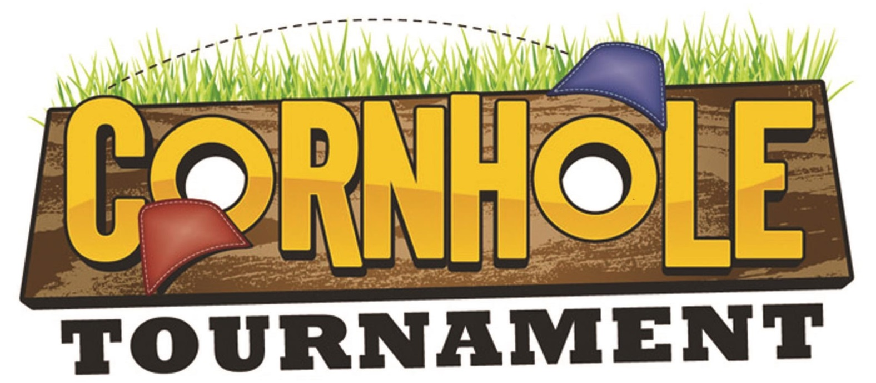

Saturday, August 4th 3:00 pm

We’re bringing this back yard favorite to the fairgrounds! Bring a friend and enter to win a cash prize.
RULES:
- Standard Corn Hole rules apply. A copy of the rules will be on-hand the day of the tournament for reference.
- Cash prizes will be awarded to 1st and 2nd place teams as well as individual prizes.
- Board and bags will be provided by Phelps County Fair for use during the tournament.
- Tournament will be Double Elimination. Initial bracket placement will be made in order registrations are received.
- Registration is limited to the first 24 teams who register. Must be 16 years or over to register.
- $20 entry fee per team must be received with registration form no later than Monday July 23, 2018. Entry fee includes a participant tee shirt. Entry fee does not include season pass or daily admission. All persons entering the fairgrounds must present a season pass (available for $25 at area businesses before the fair) or pay the daily admission fee ($15).
- All participants must arrive by 2:30 pm Saturday, August 4th to receive bracket assignment.
- Phelps County Fair will not be held liable if form is not received, lost or misdirected. Photos from the event may be used to advertise future events without compensation to participant.

Sponsors: Bottega 19 Hair & Beauty Salon; Pepsi; Trips & More Travel Agency; Farmers Insurance – Steve Bowles; Key Sport; H&R Block
Corn Hole Tournament Registration 2018
Team Name (not required) ________________________________________________

Participant Name: _______________________________________ Age: _______ T-shirt size ______

Participant Name: _______________________________________ Age: _______ T-shirt size ______

Phone: _______________________________________ email: ________________________________
Your signature below signifies your agreement to follow the rules and regulations as stated above and abide by the decision of the judges.

____________________________________________ ________________________________________
Participant Signature Participant Signature (or parent if under 18)

_________________
Date

